

Budgetary Management Subsystem

Detail Design Document

Screen design

**Project code： BMS**

**Document Code： screen_design_document-v1.0**

**<Hanoi, 29 October 2015>**

Change history

*A -Add、M - Modify、D – Delete

|  |  |  |  |  |
| --- | --- | --- | --- | --- |
| **Effective date** | **Change item** | **A* M、D** | **Changed contents** | **Version** |
| 2015/10/29 | Introduction | A | Add new | 1.0 |
|  |  |  |  |  |
|  |  |  |  |  |
|  |  |  |  |  |
|  |  |  |  |  |
|  |  |  |  |  |
|  |  |  |  |  |
|  |  |  |  |  |
|  |  |  |  |  |
|  |  |  |  |  |
|  |  |  |  |  |
|  |  |  |  |  |
|  |  |  |  |  |

Signature page

**Creater：** Phan Huy Hung <Date> : 2015/10/29

Developer

**Review：** <Name> <Date>

<Position>

<Name, if it’s needed> <Date>

<Position>

**Authorizer：** <Name> <Date>

<Position>

Table of Contents

1 Introduction 3

1.1 Purpose 3

1.2 Definitions, Acronyms and Abbreviations 3

1.3 References 3

1.4 Overview 3

2 screen flow 3

2.1 xxx screen 3

3 Other Considerations 3

# Introduction

## Purpose

This is the Screen Design Document for the “Budgetary Management Subsystem” (BMS). This document will provide the describing of screen for each function of BMS system. This specification will provide general, to be used in design and validation of the system. It is intended for both stakeholders and the project team of the system.

## Definitions, Acronyms and Abbreviations

|  |  |  |
| --- | --- | --- |
| Definition / acronym / abbreviation | Description | Note |
| TBD | To be decided | It means “not decided yet” |
|  |  |  |
|  |  |  |
|  |  |  |
|  |  |  |

## References

List all the reference document such as: other document of the system, or the technical article,...

|  |  |
| --- | --- |
| Document No. | Document Name |
|  |  |
|  |  |
|  |  |
|  |  |
|  |  |
|  |  |
|  |  |
|  |  |
|  |  |
|  |  |
|  |  |

## Overview

This document includes:

* Screen structure diagram
* List of screen and description
* Detail component of screen

# screen flow

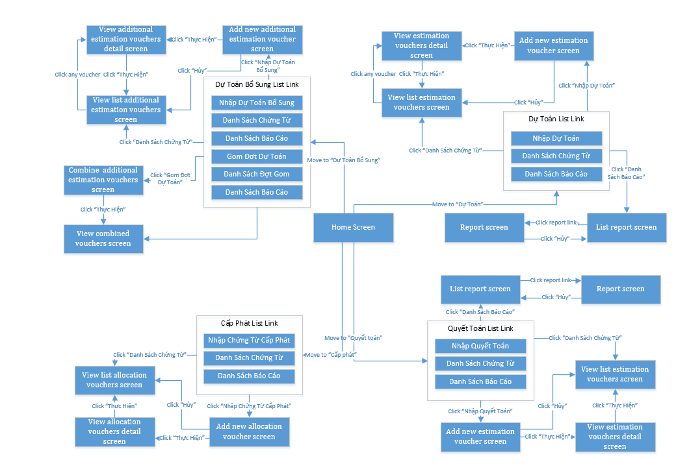

<List of screen>

|  |  |  |
| --- | --- | --- |
| No | Screen Name | Description |
| **Estimation Voucher Screen** | | |
| 1 | Add New Estimation Voucher Screen | Where allow user create new estimation voucher to save to database |
| 2 | Update Estimation Voucher Screen | Where allow user change some information of the voucher |
| 3 | View List Estimation Voucher Screen | Display list of estimation voucher |
| 4 | View Estimation Voucher Detail Screen | Display detail information of voucher |
| 5 | View List Estimation Report Screen | Display list report of estimation voucher |
| 6 | “*Tổng hợp dự toán chi ngân sách*” Report Screen | Where user choose condition and sent request to make a “*Tổng hợp dự toán chi ngân sách*” report |
| 7 | “*Báo cáo Ngân Sách bảo đảm bổ sung*” Report Screen | Where user choose condition and sent request to make a “*Báo cáo Ngân Sách bảo đảm bổ sung*” report |
| 8 | “*Chi tiêu ngân sách đảm bảo phân cấp*” Report Screen | Where user choose condition and sent request to make a “*Chi tiêu ngân sách đảm bảo phân cấp*” report |
| **Additional Estimation Voucher Screen** | | |
| 9 | Add New Additional Estimation Voucher Screen | Where allow user create new additional estimation voucher to save to database |
| 10 | Update Additional Estimation Voucher Screen | Where allow user change some information of the voucher |
| 11 | View List Additional Estimation Voucher Screen | Display list of additional estimation voucher |
| 12 | View Additional Estimation Voucher Detail Screen | Display detail information of voucher |
| 13 | View List Additional Estimation Report Screen | Display list report of additional estimation voucher |
| 14 | Add Additional Estimation Combine Voucher Screen | Where allow user create new additional estimation voucher from combine two or more additional estimation voucher |
| 15 | View Sub-Voucher of a Combine Voucher | Where allow user view list sub-voucher of a combine additional estimation voucher |
| 16 | View List Additional Estimation Report Screen | Display list report of additional estimation voucher |
| 17 | “*Chi tiêu ngân sách*” Report Screen | Where user choose condition and sent request to make a “*Chi tiêu ngân sách*” report |
| 18 | “*Tổng hợp dự toán chi tiêu ngân sách*” Report Screen | Where user choose condition and sent request to make a “*Tổng hợp dự toán chi tiêu ngân sách*” report |
| 19 | “*Bảng kiểm số liệu phân cấp*” Report Screen | Where user choose condition and sent request to make a “*Bảng kiểm số liệu phân cấp*” report |
| **Allocation Voucher Screen** | | |
| 20 | Add New Allocation Voucher Screen | Where allow user create new allocation voucher to save to database |
| 21 | Update Allocation Voucher Screen | Where allow user change some information of the allocation voucher |
| 22 | View List Allocation Voucher Screen | Display list of allocation voucher |
| 23 | View Allocation Voucher Detail Screen | Display detail information of voucher |
| 24 | View List Allocation Report Screen | Display list report of allocation voucher |
| 25 | “*Cấp Phát Thông Tri*” Report Screen | Where user choose condition and sent request to make a “*Cấp Phát Thông Tri*” report |
| **Settlement Voucher Screen** | | |
| 26 | Add New Settlement Voucher Screen | Where allow user create new settlement voucher to save to database |
| 27 | Update Settlement Voucher Screen | Where allow user change some information of the settlement voucher |
| 28 | View List Settlement Voucher Screen | Display list of settlement voucher |
| 29 | View Settlement Voucher Detail Screen | Display detail settlement of voucher |
| 30 | View List Settlement Report Screen | Display list report of settlement voucher |
| 31 | “*Báo cáo quyết toán LNS Đơn vị*” Report Screen | Where user choose condition and sent request to make a “*Báo cáo quyết toán LNS Đơn vị*” report |
| 32 | “*Quyết Toán Tổng Hợp*” Report Screen | Where user choose condition and sent request to make a “*Quyết Toán Tổng Hợp*” report |
| 33 | “*Quyết toán Tổng hợp nhập số liệu*” Report Screen | Where user choose condition and sent request to make a “*Quyết toán Tổng hợp nhập số liệu*” report |
| 34 | “*Quyết Toán Thông Tri*” Report Screen | Where user choose condition and sent request to make a “*Quyết Toán Thông Tri*” report |
| 35 | “*Quyết toán chọn Đơn vị - LNS*” Report Screen | Where user choose condition and sent request to make a “*Quyết toán chọn Đơn vị - LNS*” report |
| 36 | “*Quyết toán tổng hợp chọn LNS*” Report Screen | Where user choose condition and sent request to make a “*Quyết toán tổng hợp chọn LNS*” report |
| 37 | “*Quyết toán tổng hợp năm – quý*” Report Screen | Where user choose condition and sent request to make a “*Quyết toán tổng hợp năm – quý*” report |
| 38 | “*Quyết toán phòng ban*” Report Screen | Where user choose condition and sent request to make a “*Quyết toán phòng ban*” report |

## Estimation Voucher Screen

### Add New Estimation Voucher Screen

|  |  |  |  |  |  |
| --- | --- | --- | --- | --- | --- |
| No | Component Name | Request | Format | Reference | Note |
| 1 | sLNS | Click On | DropDownList |  | Choose budget type |
| 2 | dNgayChungTu | Click On | TextField |  | Display DatePicker to select Date with format dd/mm/yyyy |
| 3 | sNoiDung | Click On | TextField |  | Input Text |
| 4 | Submit1 | Click On | Button |  | Save new estimation voucher |

### Update Estimation Voucher Screen

|  |  |  |  |  |  |
| --- | --- | --- | --- | --- | --- |
| No | Component Name | Request | Format | Reference | Note |
| 1 | dNgayChungTu | Click On | TextField |  | Display DatePicker to select Date with format dd/mm/yyyy |
| 2 | sNoiDung | Click On | TextField |  | Input Text |
| 3 | Submit1 | Click On | Button |  | Save estimation voucher |
| 4 | Cancel1* | Click On | Button |  | Cancel update estimation voucher |

### View List Estimation Voucher Screen

|  |  |  |  |  |  |
| --- | --- | --- | --- | --- | --- |
| No | Component Name | Request | Format | Reference | Note |
| 1 | sLNS_TK | Click On | DropDownList |  | Select budget type to search |
| 2 | dTuNgay | Click On | TextField |  | Display DatePicker to select date to search estimation voucher |
| 3 | dDenNgay | Click On | TextField |  | Display DatePicker to select date to search estimation voucher |
| 4 | iID_MaTrangThaiDuyet | Click On | DropDownList |  | Select status to search estimation voucher |
| 5 | btSearch* | Click On | Button |  | Search estimation voucher |
| 6 | Dt | Click On | Datatable |  | Display list of estimation voucher with features |
| 7 | Index | Click On | ActionLink | View Estimation Voucher Detail Screen | Display budget type, date of estimation voucher detail when click on Move to View Estimation Voucher Detail Screen |
| 8 | sNoiDung |  | EnCodeString |  | Display note of estimation voucher |
| 9 | Edit | Click On | ActionLink | Update Estimation Voucher Screen | Move to Update Estimation Voucher Screen |
| 10 | Delete | Click On | ActionLink |  | Delete voucher |
| 11 | sID_MaNguoiDungTao |  | Text |  | Display id of estimation voucher creator |
| 12 | sTrangThai |  | Text |  | Display status of estimation voucher |
| 13 | sLyDo |  | Text |  | Display notice of estimation voucher |
| 14 | Trình Duyệt |  | ActionLink | Change Status Estimation Voucher Screen | Move to Change Status Estimation Voucher Screen |
| 15 | Từ Chối |  | ActionLink | Change Status Estimation Voucher Screen | Move to Change Status Estimation Voucher Screen |

### View Estimation Voucher Detail Screen

|  |  |  |  |  |  |
| --- | --- | --- | --- | --- | --- |
| No | Component Name | Request | Format | Reference | Note |
|  |  |  |  |  |  |
|  |  |  |  |  |  |
|  |  |  |  |  |  |
|  |  |  |  |  |  |

### Change Status Estimation Voucher Screen

|  |  |  |  |  |  |
| --- | --- | --- | --- | --- | --- |
| No | Component Name | Request | Format | Reference | Note |
| 1 | sLyDo | Click On | TextArea |  | Input text |
| 2 | btnDuyet | Click On | Button | View List Estimation Voucher Screen | Change status when click and move to View List Estimation Voucher Screen |
| 3 | BtnHuy | Click On | Button | View List Estimation Voucher Screen | Cancel and move to View List Estimation Voucher Screen |

### View List Estimation Report Screen

|  |  |  |  |  |  |
| --- | --- | --- | --- | --- | --- |
| No | Component Name | Request | Format | Reference | Note |
| 1 | rptDuToan_1 | Click On | ActionLink | “*Tổng hợp dự toán chi ngân sách*” Report Screen | Move to “*Tổng hợp dự toán chi ngân sách*” Report Screen |
| 2 | rptDuToan_2 | Click On | ActionLink | “*Báo cáo Ngân Sách bảo đảm bổ sung*” Report Screen | Move to “*Báo cáo Ngân Sách bảo đảm bổ sung*” Report Screen |
| 3 | rptDuToan_3 | Click On | ActionLink | “*Chi tiêu ngân sách đảm bảo phân cấp*” Report Screen | Move to “*Chi tiêu ngân sách đảm bảo phân cấp*” Report Screen |

### “*Tổng hợp dự toán chi ngân sách*” Report Screen

|  |  |  |  |  |  |
| --- | --- | --- | --- | --- | --- |
| No | Component Name | Request | Format | Reference | Note |
| 1 | iID_MaDot | Click On | DropDownList |  | Select phase |
| 2 | iID_MaPhongBan | Click On | DropDownList |  | Select division |
| 3 | LoaiTongHop | Click On | OptionBox |  | Select kind report |
| 4 | sLNS | Click On | CheckBoxList |  | Select budget kind |
| 5 | tdDonVi | Click On | CheckBoxList |  | Select Unit |
| 6 | Submit2 | Click On | Button |  | Submit to create report |
| 7 | btCancel | Click On | Button | View List Estimation Report Screen | Cancel create report and move to View List Estimation Report Screen |

### “*Báo cáo Ngân Sách bảo đảm bổ sung*” Report Screen

|  |  |  |  |  |  |
| --- | --- | --- | --- | --- | --- |
| No | Component Name | Request | Format | Reference | Note |
| 1 | iID_Dot | Click On | DropDownList |  | Select phase |
| 2 | iID_MaPhongBan | Click On | DropDownList |  | Select division |
| 3 | LoaiTongHop | Click On | OptionBox |  | Select kind report |
| 4 | tdDonVi | Click On | CheckBoxList |  | Select Unit |
| 5 | Submit2 | Click On | Button |  | Submit to create report |
| 6 | btCancel | Click On | Button | View List Estimation Report Screen | Cancel create report and move to View List Estimation Report Screen |

### “*Chi tiêu ngân sách đảm bảo phân cấp*” Report Screen

|  |  |  |  |  |  |
| --- | --- | --- | --- | --- | --- |
| No | Component Name | Request | Format | Reference | Note |
| 1 | Nganh | Click On | DropDownList |  | Select branch |
| 2 | tdDonVi | Click On | CheckBoxList |  | Select sheet |
| 3 | iID_MaPhongBan | Click On | DropDownList |  | Select department |
| 4 | MaDot | Click On | DropDownList |  | Select budgetary session |
| 5 | btSubmit | Click On | Button |  | Submit to create report |
| 6 | btCancel | Click On | Button | View List Estimation Report Screen | Cancel create report and move to View List Estimation Report Screen |

## Additional Estimation Voucher Screen

Add New Additional Estimation Voucher Screen

|  |  |  |  |  |  |
| --- | --- | --- | --- | --- | --- |
| No | Component Name | Request | Format | Reference | Note |
|  |  |  |  |  |  |
|  |  |  |  |  |  |
|  |  |  |  |  |  |
|  |  |  |  |  |  |

Update Additional Estimation Voucher Screen

|  |  |  |  |  |  |
| --- | --- | --- | --- | --- | --- |
| No | Component Name | Request | Format | Reference | Note |
|  |  |  |  |  |  |
|  |  |  |  |  |  |
|  |  |  |  |  |  |
|  |  |  |  |  |  |

View List Additional Estimation Voucher Screen

|  |  |  |  |  |  |
| --- | --- | --- | --- | --- | --- |
| No | Component Name | Request | Format | Reference | Note |
|  |  |  |  |  |  |
|  |  |  |  |  |  |
|  |  |  |  |  |  |
|  |  |  |  |  |  |

View Additional Estimation Voucher Detail Screen

|  |  |  |  |  |  |
| --- | --- | --- | --- | --- | --- |
| No | Component Name | Request | Format | Reference | Note |
|  |  |  |  |  |  |
|  |  |  |  |  |  |
|  |  |  |  |  |  |
|  |  |  |  |  |  |

View List Additional Estimation Report Screen

|  |  |  |  |  |  |
| --- | --- | --- | --- | --- | --- |
| No | Component Name | Request | Format | Reference | Note |
|  |  |  |  |  |  |
|  |  |  |  |  |  |
|  |  |  |  |  |  |
|  |  |  |  |  |  |

View List Additional Estimation Report Screen

|  |  |  |  |  |  |
| --- | --- | --- | --- | --- | --- |
| No | Component Name | Request | Format | Reference | Note |
|  |  |  |  |  |  |
|  |  |  |  |  |  |
|  |  |  |  |  |  |
|  |  |  |  |  |  |

“*Chi tiêu ngân sách*” Report Screen

|  |  |  |  |  |  |
| --- | --- | --- | --- | --- | --- |
| No | Component Name | Request | Format | Reference | Note |
| 1 | iID_MaDot | Click On | DropDownList |  | Select budgetary session |
| 2 | iID_MaPhongBan | Click On | DropDownList |  | Select department |
| 3 | tdDonVi | Click On | CheckBoxList |  | Select unit |
| 4 | tdLNS | Click On | CheckBoxList |  | Select budget kind |
| 5 | Submit2 | Click On | Button |  | Submit to create report |
| 6 | btCancel | Click On | Button | View List Addition Estimation Report Screen | Cancel create report and move to View List Addition Estimation Report Screen |

“*Tổng hợp dự toán chi tiêu ngân sách*” Report Screen

|  |  |  |  |  |  |
| --- | --- | --- | --- | --- | --- |
| No | Component Name | Request | Format | Reference | Note |
| 1 | iID_MaDotTu | Click On | DropDownList |  | Select budgetary session |
| 2 | iID_MaDotDen | Click On | DropDownList |  | Select budgetary session |
| 3 | iID_MaPhongBan | Click On | DropDownList |  | Select department |
| 4 | tdDonVi | Click On | CheckBoxList |  | Select unit |
| 5 | tdLNS | Click On | CheckBoxList |  | Select budget kind |
| 6 | Submit2 | Click On | Button |  | Submit to create report |
| 7 | btCancel | Click On | Button | View List Addition Estimation Report Screen | Cancel create report and move to View List Addition Estimation Report Screen |

“*Bảng kiểm số liệu phân cấp*” Report Screen

|  |  |  |  |  |  |
| --- | --- | --- | --- | --- | --- |
| No | Component Name | Request | Format | Reference | Note |
| 1 | iID_MaDot | Click On | DropDownList |  | Select budgetary session |
| 2 | tdDonVi | Click On | CheckBoxList |  | Select unit |
| 3 | iID_MaPhongBan | Click On | DropDownList |  | Select department |
| 4 | tdLNS | Click On | CheckBoxList |  | Select budget kind |
| 5 | Submit2 | Click On | Button |  | Submit to create report |
| 6 | btCancel | Click On | Button | View List Addition Estimation Report Screen | Cancel create report and move to View List Addition Estimation Report Screen |

## Allocation Voucher Screen

## Settlement Voucher Screen

<Screen picture>

<screen’s component list, table below is suggestion>

|  |  |  |  |  |  |
| --- | --- | --- | --- | --- | --- |
| No | Component Name | Request | Format | Reference | Note |
|  |  |  |  |  |  |
|  |  |  |  |  |  |
|  |  |  |  |  |  |
|  |  |  |  |  |  |

# Other Considerations

[This section provides a description of other design elements that were considered as alternatives in selection process for the above screen design, i.e. a brief explanation of advantages and disadvantages of the selected screen flows and/or screen GUI element implementation in comparison with others. It should be a clear answer to the question why the above screen design is selected for this system, not the others.]